
Introduction to DOSBox
Lab 6

Computer Organization and Assembly Language

Student Name | Muhammad Hassan Khalid
Registration # | 21L-5692
Instructor | Hazoor Ahmad
Class | CS3
Section | A1, A2, D1, D2
Semester | Fall 2022

Fast School of Computing
FAST-NU, Lahore, Pakistan

Activity 3

Assembly Language Code
[org 0x0100]

jmp start

clearscreen:
mov ax, 0xb800
mov es, ax
mov di, 0

nextchar:
mov word [es:di], 0x0720
add di, 2
cmp di, 4000
jne nextchar
ret

printchar:
mov word [es:di],0x075F
add di,2
cmp di,2080
jne printchar
ret

printchar2:
mov word [es:di],0x072E
add di,2
cmp di,4000
jne printchar2
ret

start:
call clearscreen

call printchar

call printchar2

mov ax, 0x4c00
int 0x21

Debugging Screenshots
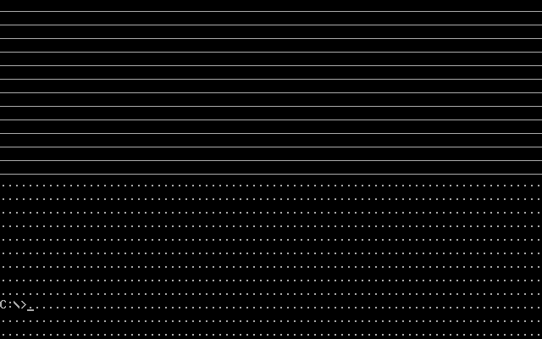

Activity 4

Assembly Language Code
[org 0x0100]

jmp start

clearscreen:
mov ax, 0xb800
mov es, ax
mov di, 0

nextchar:
mov word [es:di], 0x0720
add di, 2
cmp di, 4000
jne nextchar
ret

printchar:
mov ah,0x07
mov al,0x00
l1:
mov word [es:di],ax
add al,1
add di,2
cmp di,4000
jne l1
ret

start:
call clearscreen

call printchar

mov ax, 0x4c00
int 0x21

Debugging Screenshots
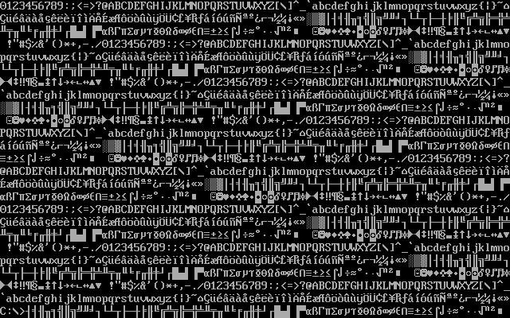

Activity 5

Assembly Language Code
[org 0x0100]

jmp start

clearscreen:
mov ax, 0xb800
mov es, ax
mov di, 0

nextchar:
mov word [es:di], 0x0720
add di, 2
cmp di, 4000
jne nextchar
ret

printchar:
mov ah,0x8F
mov al,0x00
l1:
mov word [es:di],ax
add al,1
add di,2
cmp di,4000
jne l1
ret

start:
call clearscreen

call printchar

mov ax, 0x4c00
int 0x21

Debugging Screenshots
